Day of the Dead Project Guidelines 8th grade Spanish

Create a Google Slideshow. Choose one of the following:

1. Vocabulary Slideshow

- At least 10 slides and no more than 15 slides
- Vocabulary - at least 10 Spanish Day of the Dead words
- At least 5 images with all sources cited under the image

2. Compare/contrast Show

- At least 10 slides and no more than 15 slides
- Compare and contrast Day of the Dead to Halloween
- At least 5 images with all sources cited under the image

3. Tombstone or Obituary SlideShow

- At least 10 slides and no more than 15 slides
- On the tombstone or in the obituary slide show, include biographical information about a famous Hispanic person’s life and what made them famous.
- At least 5 images with all sources cited under the image

4. First Person Slideshow

- At least 10 slides and no more than 15 slides
- In the slideshow pretend to be the famous Hispanic person. Write in first person and tell a story about “yourself”. You can also dress up as the person for 10 extra bonus points.
- At least 5 images with all sources cited under the image

- You will need at least 5 images with all sources cited under the image.
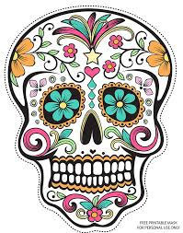
To cite your image,
you will need the following:
Name of image.
Source of image.
Date Retrieved
(This is the date you
found the image.)

Example:

Sugar Skull Day of the Dead image.
Source: https://s-media-cache-ak0.pinimg.com
Date Retrieved: October 26, 2016

When you research and find information, you must give credit to your source. At the bottom of each slide where you have typed your research (otherwise known as your answers), you will need to have a SOURCE.

You will TURN IN your SLIDESHOW to classroom.google.com

