Day of the Dead Project Guidelines 7th grade Spanish

1. Create a Google Slideshow that consists of the following:

- At least 10 slides and no more than 15 slides
- An introduction and history of Day of the Dead (Día de los Muertos).
In that introduction and history, be sure to answer these questions…

Who? What? When? Where? Why? How?

Who celebrates Day of the Dead?
What is Día de los Muertos?
When is Day of the Dead?
Where is Day of the Dead celebrated?
Why do people celebrate Day of the Dead?
How do people celebrate Day of the Dead?
- You will need at least 5 images with all sources cited under the image.
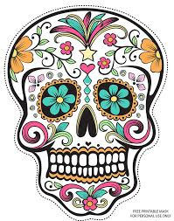
To cite your image,
you will need the following:
Name of image.
Source of image.
Date Retrieved
(This is the date you
found the image.)

Example:

Sugar Skull Day of the Dead image.
Source: https://s-media-cache-ak0.pinimg.com
Date Retrieved: October 26, 2016

When you research and find information, you must give credit to your source. At the bottom of each slide where you have typed your research (otherwise known as your answers), you will need to have a SOURCE.

You will TURN IN your SLIDESHOW to classroom.google.com

